Dinosaurs on the Great Tea Way
Paleontology is the science that studies the remains of organisms. Paleontological findings allow us to restore the appearance of extinct animals, their structure, similarities and differences with modern ones. So we can see the development of the organic world in time.
1989 Alexey Starkov conducted excavations on Gusinoe Island and found a vertebra belonging to a representative of Titanosaurs. It is a long-necked lizard about 12 meters long and weighing about 20 tons. Later it was named Tengrisaurus - Tengrisaurus starkovi, Tengri is the name of the supreme deity in the Turkic-Mongolian religion, the sky god Tengri, the type species, the second part of the name in honor of the Buryat scientist paleontologist Alexei Starkov.
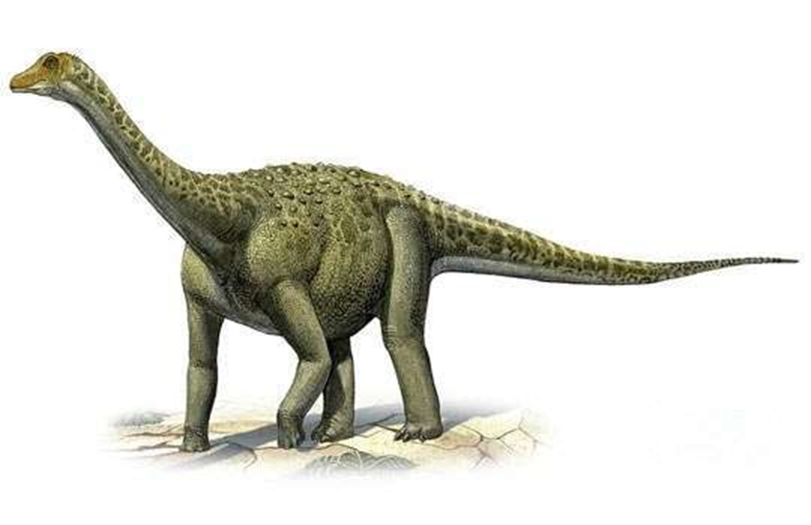
photo from extinct-animals.fandom.com
The joint work continued with the students of Nesova, Alexander Averyanov and Pavel Kutas. The remains of psittacosaurs, lizards, aquatic and other reptiles, as well as the oldest mammals were found there in 1998, 1999 and 2002.
Tengrisaurs had a long neck, and they reached 20 meters in length, and their weight could reach 40 tons. Despite their impressive size, these representatives of the prehistoric fauna were herbivores. By the way, even children know this group of dinosaurs - animators often use the image of a reptile for their plots.
A small fragment of bone sticking out of the cliff. I hope there may be other remnants of this giant here. But we will find out about this only during the next trip – it is planned for 2020," Alexander said.
Now scientists are going to thoroughly investigate the find. Unfortunately, only a fragment of the thigh has survived to our time, so it will be reconstructed: the shattered bone will be put together, and the missing parts will be replaced with plastic. After that, the remains will be scanned on a 3D scanner and sent to St. Petersburg and foreign colleagues-scientists for comparison with the bones of other "brothers" of the Goose Lake prehistoric giant. For example, in Mongolia and China, even whole skeletons of his closest relatives are found.
Dinosaurs! It is difficult to find a person who has not heard about these huge monsters that lived on the planet millions of years ago. A great many materials have been written about the life of dinosaurs. They became the heroes of adventure novels, fantasy films and cartoons.
Theoretically, dinosaurs lived all over the planet, but their remains are being found more and more in the sands and deserts. Due to the climatic features, they are better preserved there. One of these places where dinosaurs lived "became" the Gobi Desert. It is located in Mongolia.
The first Mongolian dinosaur was discovered in the 20s of the last century. It was found by American scientists under the leadership of R.Andrews. In the present, the find is kept at the Metropolitan Museum of New York.
In turn, Russians should be pleased with the following fact — the honor of the first discovery of fossil vertebrates belongs to Russian travelers and geologists, and of them, first of all, V. A. Obruchev, who found the first tooth of a tertiary rhinoceros in the red-colored Gobi fields of Mongolia.
Dinosaur bones found on the territory of Mongolia adorn the museums of St. Petersburg, Warsaw and other cities. As for Mongolia itself, it has not had its own museum for a long time, and only on February 21, 2013, the Central Museum of Mongolian Dinosaurs finally opened in Ulaanbaatar. It is located in the city center, a 15-minute walk from Sukhbaatar Square.
Mongolia has been sending its dinosaurs to exhibitions in different parts of the world for more than 20 years, while there was no museum in the country. The authorities heard such a serious bell, after which they opened the museum.
Dinosaurs multiplied by laying eggs. Some individuals laid more, some less, but, according to museum workers, one clutch of tarbosaurus was about 100 eggs. It is not known for sure, but the dominant version is that dinosaurs, like turtles, did not hatch their offspring.
To Baikal
More than a billion years ago, the territory of Buryatia was covered with water. Much more information exists on the beginning of the Paleozoic era (450- 550 million years ago). Our region was covered by the sea, and it was only towards the end of the early Paleozoic that the movements of the earth's crust began, thanks to which land areas appeared in Transbaikalia. In the later deposits of the Permian and Triassic periods (from 210 to 280 million years ago), organic remains, except for spores and pollen of plants, could not be found.
The deposits of the Jurassic and Cretaceous periods of the Mesozoic era provide more information about the ancient fauna and flora of the region. A number of basins in the southern part of western Transbaikalia are rich in them. So, in the Mukhorshibir basin, the remains of various plants, insects, fish and, possibly, amphibians or small reptiles were found. The presence of dinosaurs is also quite likely, especially since the territory of Buryatia at that time was similar to the tropical one. However, dinosaur bones were found only in sediments of the Early Cretaceous epoch 105-130 million years ago. They are widely distributed in the Gusinoozersk basin, which has become a real treasure in this regard, along the valley of the Jida and Kirana rivers, on lower sections in the Bichurskaya, most of the Orongoi-Ubukun and Ivolginskaya basins, on the starboard side of the Uda (including Ulan-UDE).
As for dinosaurs, there were relatively small ones, for example, ostrich-like lizards from the group of ornithommosaurs and dromaeosaurids, and larger therizinosaurids, distinguished by large claws. Large predators are also not excluded. So, the first find in Transbaikalia in the form of a metatarsal bone was discovered at the beginning of the XX century and attributed it specifically to the North American genus - allosaurus. Subsequently, the remains began to be attributed to another - tsilantaysaurus, which lived on the territory of modern China. Scientists believe that large predators should be searched for in the territory of the Bichursky district.
Among the herbivorous sauropod lizards, there were euhelops, Mongolosaurus and the already mentioned tengrisaurus. In general, according to scientists, the size of the long-necked in Buryatia hardly exceeded 20 meters. Fragmentary remains of dinosaurs from the group of ornithopods, small hypsilophodontids and other groups, such as large iguanodons, are known. There were also widespread relatives of horned dinosaurs – psittacosaurs.
Today it is absolutely possible to say that dinosaurs lived on the territory of three modern districts of Buryatia. They also inhabited other places in the distant past, perhaps. Deposits of the Lower Cretaceous age indicate that ancient animals could have lived quite well on the lands of the Dzhidinsky, Mukhorshibirsky, Kyakhtinsky, Ivolginsky, Zaigraevsky, Khorinsky districts and Ulan-Ude.
The "Great Tea Way– is a caravan route that took place in the XVI-XIX centuries between Asia and Europe.
The history of the "Great Tea Way" is one of the brightest pages in the history of the development of diplomatic, trade, and cultural ties between the peoples of Eurasia.
The geography of the "Great Tea Way" is very extensive. The beginning of the journey was in the city of Wuhan and branched into several land and water routes that passed through more than 150 cities. The movement of caravans from Russia to China and from China to Russia went through Moscow, Pereslavl-Zalessky, Yaroslavl, Kostroma, Turinsk, Tyumen, Tobolsk, Tomsk, Omsk, Ishim, Novosibirsk, Krasnoyarsk, Kansk, Yeniseisk, Ilimsk, Nizhneudinsk, Irkutsk, Verkhneudinsk, Selenginsk, Kyakhta, Sainshand, Urga, Eren-Hoto, Kalgan, Beijing and other cities. There were more than 12 trade fairs on the way, the most famous were: Kyakhtinskaya, Verkhneudinskaya, Irkutsk, Yenisei, Mangazeyskaya, Tarskaya, Surgut, Turukhanskaya, Irbit, Makaryevskaya, Moscow.
A common line can be drawn from Wuhan to Beijing, then to Hohhot, Urga (now Ulanbaatar), Darkhan, Troitskosavsk (now Kyakhta). Kyakhta was once the main trade center of the Tea Route, it was not for nothing that it was called the "Russian capital of tea". From Kyakhta, the route followed to Verkhneudinsk (now Ulan-UDE) and further to Krasnoyarsk, Nizhny Novgorod, Moscow and St. Petersburg.
In other words, this trans-Mongolian railway, like the old Tea Way, successfully performs the function of the main trade highway connecting not only Russia with China, but also Europe with Asia. The development of modern Mongolia is directly connected with this railway. The houses and buildings of today's Ulaanbaatar, factories and plants in Darkhan, the flagship of the Mongolian industry - the joint mining and processing plant "Erdenet" - were built thanks to her.

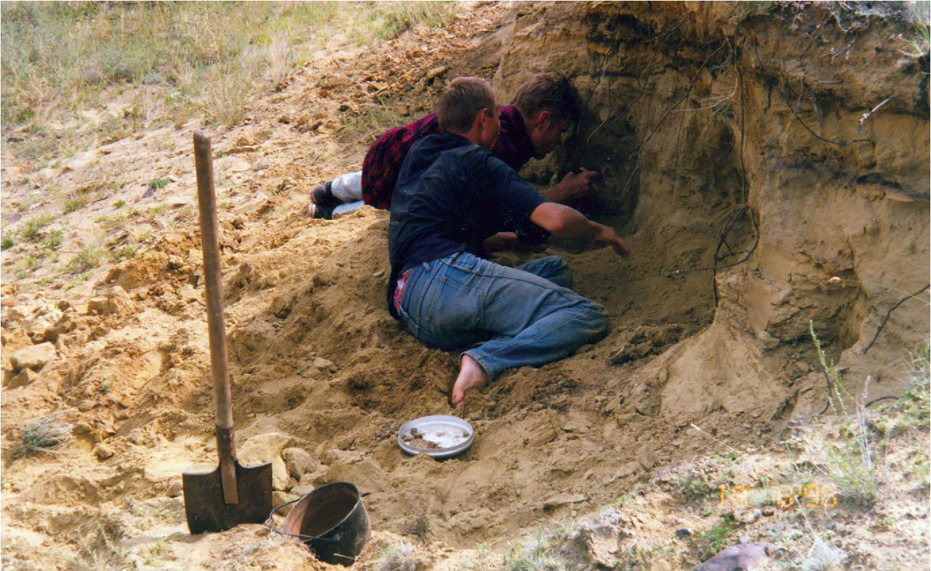
Scientists from St. Petersburg on excavations in Buryatia
photo from semanticscholar.org
After the Big Bang
About 65 million years ago, the largest extinction of living organisms occurred on Earth. Along with the dinosaurs, marine reptiles, flying lizards, most mollusks and small algae disappeared. Only small reptiles managed to survive: snakes, turtles and crocodiles. The Mesozoic ecosystem was completely destroyed, and the vacated food niches were occupied by birds and mammals, which subsequently developed a huge variety of forms in the Cenozoic.
At the beginning of this era (45-60 million years ago), only deposits with spores and pollen of plants were found on the territory of Buryatia, but towards the end of the Eocene, about 20-35 million years ago, the geography of the locations expanded, in particular, they appear near the newly formed Baikal, and in Northern Transbaikalia. The composition of the plants of that period indicates a warmer climate than it is now. However, at the end of the Pliocene (about 3 million years ago), heat-loving plants completely disappear, and already in the Eopleistocene (from 500 thousand to 2.5 million years ago), vegetation acquires an almost modern appearance.
The climate of that time in Buryatia was warm and resembled savannas. There lived a large saber-toothed cat - homotherium and a primitive elephant - stegodon, a three-toed horse - hipparion, rhinoceroses, screw-horned antelopes, gazelles, deer, polorogies and, finally, a narrow-nosed monkey related to the Indian langur.
In other localities of this age there are insectivores, predators of the wolf family, other species of cats and hyenas. One of them turned out to be right in the center of Ulan-Ude. So, a few years ago, in the area of Pobedy Avenue, while digging a trench, the remains of a gazelle and a hipparion were found. With the beginning of the Pleistocene, the latter were replaced by real horses, new forms of rhinoceroses, elephants and large cats appeared, modern genera of deer and hornbills, rodents and hares.
No long before humans
With the beginning of the cold snap, along with early elephants, trogonterium mammoths appear - the ancestors of woolly mammoths, as well as the ancestors of woolly rhinoceroses - Tologoi rhinoceroses. And in the Middle Pleistocene - already real mammoth and woolly rhinoceros.
At the same time, early groups of elephants, rhinoceroses and other ungulates, as well as some predators, including saber-toothed cats, are disappearing. Their place is taken by the panthers, close to the cave lion. Ostriches, eagles and several species of ducks are known from the remains of birds. In the late Pleistocene, the Lena horse, widespread in Eastern Siberia, saiga and reindeer, along with mammoth, woolly rhinoceros and primitive bison, shared the territory near Lake Baikal. From this moment, almost all modern species of large and small mammals, familiar to the nature of Buryatia today, are formed.
Dinosaurs multiplied by laying eggs. Some individuals laid more, some less, but, according to museum workers, one clutch of tarbosaurus was about 100 eggs. It is not known for sure, but the dominant version is that dinosaurs, like turtles, did not hatch their offspring.
Anton Irshutov, with
the assistance of the leading engineer of the Laboratory of
Ecology and Systematics of Animals of the BNC
Alexey Starkov
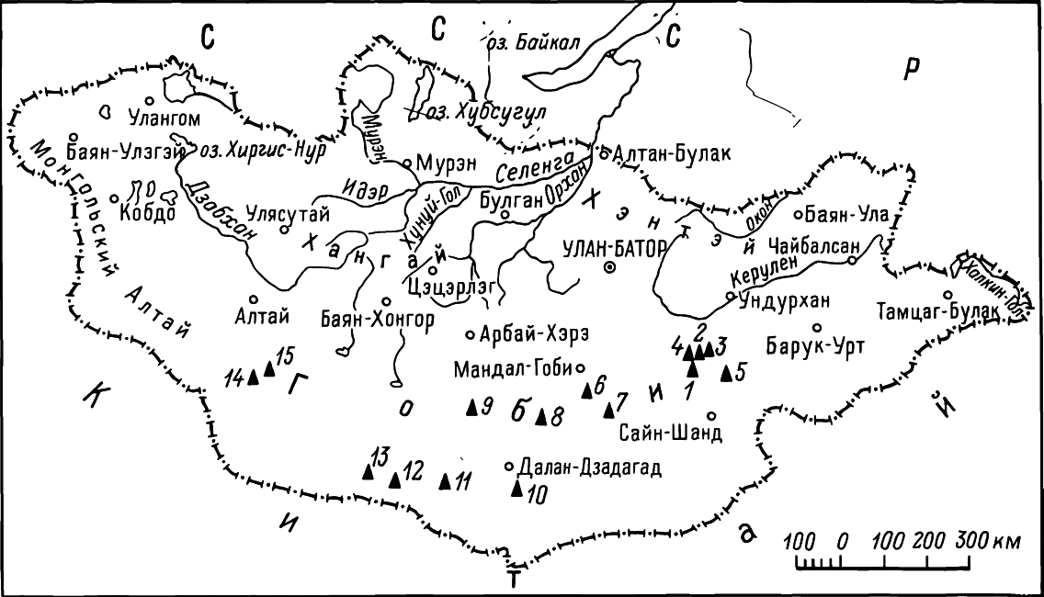
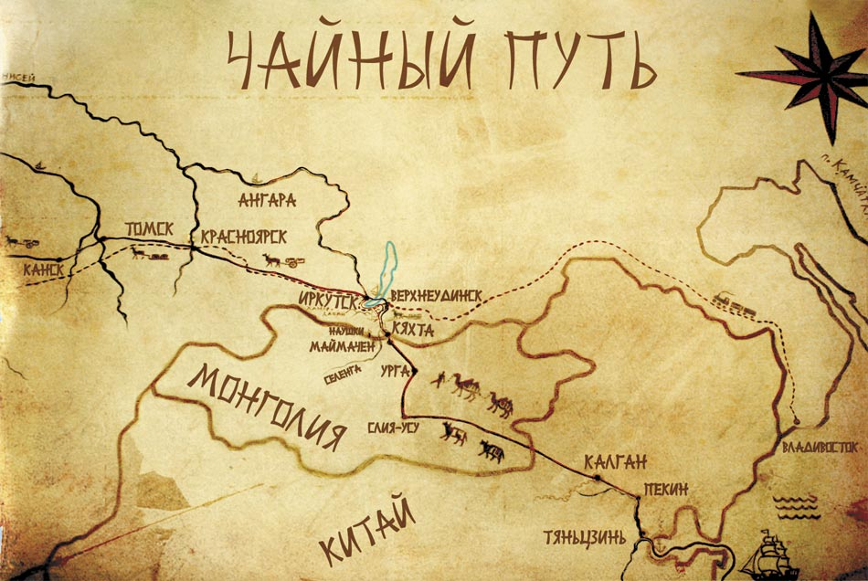
Literature and resources

Dorzhieva T.S., Dorzhieva G.S. Toponymy of the tea way on the territory of Buryatia. - Ulan-Ude; Buryat State University Publishing House, 2015.-172 p. - bibliography.: pp. 156-170. 2016.02.030.
Budaeva Anastasiia, grade 11 «B», Buryat gymnasium №29,
Republic of Buryatia, Russian Federation
Octoder 2021

https://cyberleninka.ru/article/n/chaynyy-put-na-territorii-buryatii-istoriya-i-toponimiya/viewer

https://world-of-baikal.ru/index.php/zhurnal-mir-bajkala/kazhdomu-turistu-po-suveniru/724-udunginskij-kupecheskij-trakt-kyakhta-mysovaya-blizhajshij-put-k-bajkalu-cherez-otrogi-khamar-dabana

https://www.infpol.ru/102414-buryatiya-yurskogo-perioda-karta-obitaniya-dinozavrov-/

https://zen.yandex.ru/media/id/5e2701a4b477bf00adce2566/chainyi-put-kitaia-5e4dec975033cf582d8769e5

https://maps-creator.com/maps/w65Ae25

https://ru.wikipedia.org/

https://burunen.ru/news/society/65246-era-dinozavrov-kakie-drevnie-zhivotnye-obitali-na-territorii-buryatii/

https://asiarussia.ru/articles/11590/
https://bur.aif.ru/society/details/tayny_gusinogo_ozera_chto_skryvaetsya_v_glubine_buryatskogo_vodoyoma

